

TED UNIVERSITY

Faculty of Engineering

Department of Computer Engineering

**CMPE 399 – Summer Training Report**

by

Berk KAYA

HAVELSAN A.Ş.

From 04/08/2025 To 19/09/2025

Submission Date

Table of Contents

2 Introduction 3

2.1 Overall Goal 3

2.2 Expected Learning Outcomes (LOs) 3

3 The Company/Course Information 4

3.1 General 4

3.1.1 Historical background (for companies) 4

3.1.2 Engineering Units (for companies) 4

3.2 Products and Services (for companies) 4

3.3 Work Environment (for companies) 4

4 Assigned Tasks and Projects 5

4.1 Problem Definition 5

4.2 Knowledge Integration 5

4.2.1 Knowledge Integration with Course Work 5

4.2.2 Learned Tools and Technologies 5

4.2.3 Self Learning 5

4.3 Work Plan and Timeline 5

4.4 Implementation 5

4.4.1 Literature review and Data Collection 5

4.4.2 Implementation 5

4.5 Evaluation & Impact Analysis 5

5 Conclusions & Recommendations 6

6 References 7

# Introduction

## Overall Goal

A simple, clear, brief, positive, and correctly written statement, that describes the "big-picture" idea of why the student is interested to have training, what he wants to focus on, and what he needs to accomplish.

New paragraph comes here.....



Figure 1: Figure example. Give figure explanation. Image is taken from [1].

## Expected Learning Outcomes (LOs)

Three or more correctly written learning outcomes that describe specific, measurable, and realistic achievements to accomplish during the training experience. They relate to the job, represent the job functions and duties, assist in professional growth and development, relate to the student's course of study or major, and help to reach the overall goal of student's training experience. Please be aware that this section should rely not only the below wirtten (see Fig. 1) LOs on but also your own expectations from this summer practice.

# The Company Information

## General

Mustafa Kemal, Şht. Öğretmen Şenay Aybüke Yalçın Cd. No:39, 06510 Çankaya/Ankara. Havelsan A.Ş.,Ezgi Tekeli, Leader Software Engineer, [etekeli@havelsan.com.tr](mailto:etekeli@havelsan.com.tr) .

### Historical background

Founded in 1982 as a subsidiary of the Turkish Armed Forces Foundation, HAVELSAN is one of Türkiye's leading technology companies. With its long-standing experience and extensive human resources, it provides high-tech, software-intensive products, solutions, and services for the public and private sectors, both domestically and internationally.

### Engineering Units

Engineering units are described in details with their functions and organizational structure.

................

## Products and Services

## Work Environment

Physical conditions of the environement, number of people working in the room can be given here.

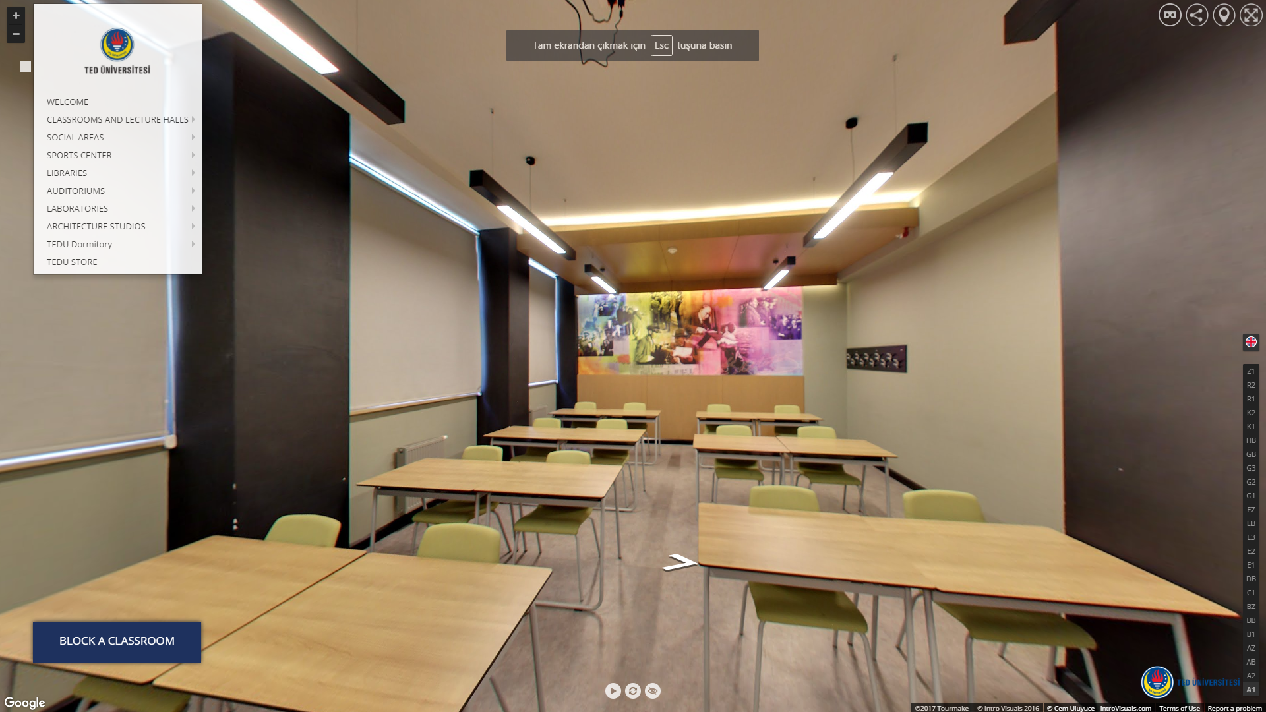

Figure 2: Figure example. Give figure explanation. Image is taken from [2]. Please refer to figures by their number (i.e., please see Figure 1 or “as explained in Fig. 1”). Do not refer to figures as "the figure below" or "the figure above." Refering to your figures is mandatory. Place the figure close as possible to the part of text referencing it. Centre the image.

# Assigned Tasks and Projects

## Problem Definition

The nature of the activities carried out by the department(s) or unit(s) where the major part of the training experience took place, is clearly described. Whether the function of the department is design, maintenance, R&D, project management, or anything else, the student is able to relate it to the activities of the whole company / establishment.

New paragraph comes here....

## Knowledge Integration

This section explains the details of the knowledge integration with course work, learned tools and technologies together with the self learning of the student.

### Knowledge Integration with Course Work

### Learned Tools and Technologies

### Self Learning

## Work Plan and Timeline

|  |  |  |  |
| --- | --- | --- | --- |
| **Task** | **Start** | **End** | **Duration** |
| Task 1 | 15.06.2017 | 21.06.2017 | 1 week |
| Task 2 | 22.06.2017 | 28.06.2017 | 1 week |
| Task 3 | 29.06.2017 | 05.07.2017 | 1 week |
| Task 4 | 06.07.2017 | 13.07.2017 | 1 week |

Table 1: Table example. Give table explanation.

Here you can create the corresponding Gannt Chart for Table 1.

## Implementation

This section discusses the actual implementation details together with corresponding literature review and data collection.

### Literature review and Data Collection

### Implementation

### This section is very important. Give clear problem definition and describe every step that you took to solve the problem. Every Figure given should be referenced in the text (you should discuss about the figure in the text.)

## Evaluation & Impact Analysis

# Conclusions & Recommendations

Achievement of Expected LOs , recommendations to enhance future training in this company together with ethical issues and finally the recommendations to enhance future training of TEDU enginering students are discussed in this section. You can either use separate subsections or you can mention all subtopics in a single section.

# References

[1]: Code image. (Access date: 2017, June 15). Retrieved from <http://dailygenius.com/tag/code/>

[2]: TEDU Prospective Students. (Access date: 2017, June 15). Retrieved from <https://aday.tedu.edu.tr/tr/aday>